Dokumentimi I detyrave te shtepise.

# Kapitulli 5

# Conditional Statements

Prof:Muzafer Shala

Ass:Laberion Zebica Student:Adhurim Haziri

Kampusi:FERIZAJ

1. Write an **if**-statement that takes two integer variables and **exchanges** their values if the first one is greater than the second one.

using System;

namespace detyra1

{

class Program

{

static void Main(string[] args)

{

Console.WriteLine("jepeni numrin e pare");

int a = Convert.ToInt32(Console.ReadLine());

Console.WriteLine("jepeni numrin e dyte");

int b = Convert.ToInt32(Console.ReadLine());

if (a > b)

{

a = a + b;

b = a - b;

a = a - b;

}

Console.WriteLine("Numri i pare:{0}\n Numri i dyte:{1};", a, b);

}

}

}

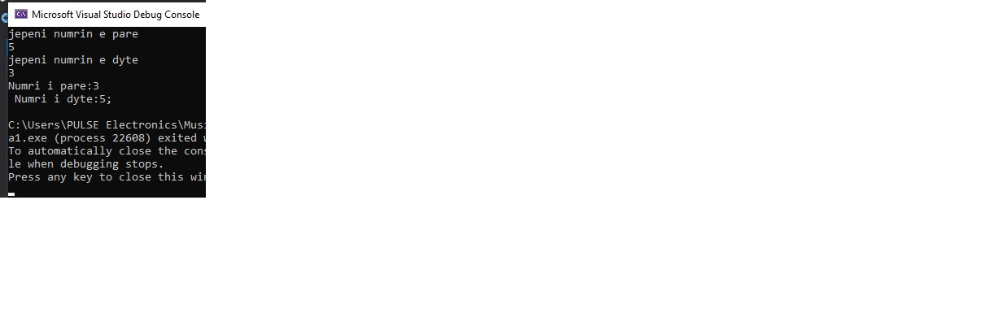

1. Write a program that shows the sign (**+** or **-**) of the product of three real numbers, without calculating it. Use a sequence of **if** operators.

using System;

namespace detyra2

{

class Program

{

static void Main(string[] args)

{

Console.Write("Enter first number: ");

int a = Int32.Parse(Console.ReadLine());

Console.Write("Enter second number: ");

int b = Int32.Parse(Console.ReadLine());

Console.Write("Enter third number: ");

int c = Int32.Parse(Console.ReadLine());

if (a < 0 && b < 0 && c < 0) Console.WriteLine("-");

else if (a >= 0 && b >= 0 && c >= 0) Console.WriteLine("+");

else if (a < 0 && b < 0 && c >= 0) Console.WriteLine("+");

else if (a < 0 && b >= 0 && c < 0) Console.WriteLine("+");

else if (a >= 0 && b < 0 && c < 0) Console.WriteLine("+");

else if (a < 0 && b >= 0 && c >= 0) Console.WriteLine("-");

else if (a >= 0 && b < 0 && c >= 0) Console.WriteLine("-");

else if (a >= 0 && b >= 0 && c < 0) Console.WriteLine("-");

}

}

}

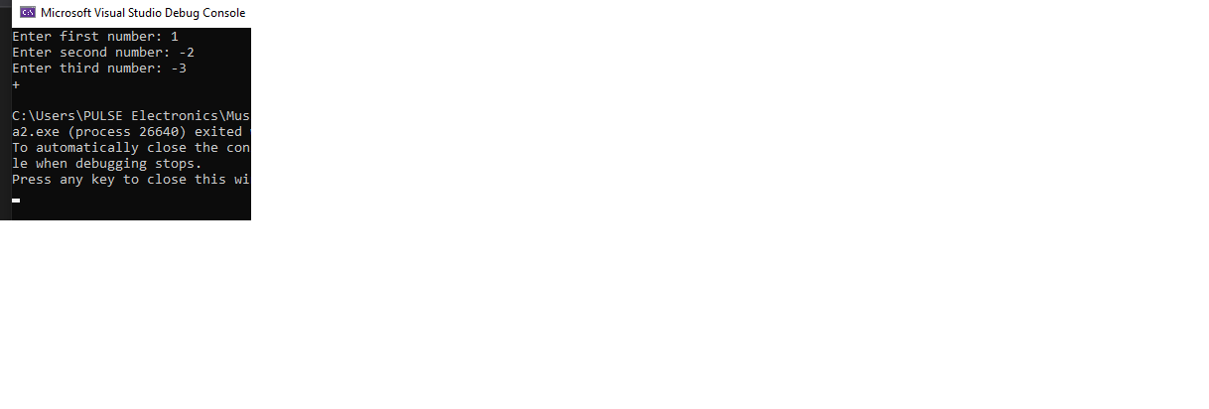

1. Write a program that finds the **biggest of three integers**, using nested **if** statements.

using System;

namespace detyra3

{

class Program

{

static void Main(string[] args)

{

Console.Write("Enter first number a: ");

int a = Int32.Parse(Console.ReadLine());

Console.Write("Enter second number b: ");

int b = Int32.Parse(Console.ReadLine());

Console.Write("Enter third number c: ");

int c = Int32.Parse(Console.ReadLine());

if (a > b)

if (a > c) Console.WriteLine("A is the biggest");

else if (a < c) Console.WriteLine("C is the biggest");

else Console.WriteLine("A and C are the biggest");

else if (a < b)

if (b > c) Console.WriteLine("B is the biggest");

else if (b < c) Console.WriteLine("C is the biggest");

else Console.WriteLine("B and C are the biggest");

else if (a == b)

if (a == c) Console.WriteLine("All are equal");

else if (a < c) Console.WriteLine("C is the biggest");

else Console.WriteLine("A and B are the biggest");

}

}

}

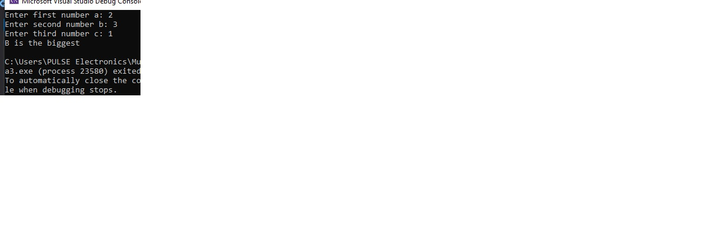

1. **Sort 3 real numbers** in descending order. Use nested **if** statements.

using System;

namespace detyra4

{

class Program

{

static void Main(string[] args)

{

Console.Write("Enter first number a: ");

int a = Int32.Parse(Console.ReadLine());

Console.Write("Enter second number b: ");

int b = Int32.Parse(Console.ReadLine());

Console.Write("Enter third number c: ");

int c = Int32.Parse(Console.ReadLine());

if (a < b)

{

if (a < c)

{

a = a + c;

c = a - c;

a = a - c;

if (b > c)

{

a = a + b;

b = a - b;

a = a - b;

}

}

else if (a >= c)

{

a = a + b;

b = a - b;

a = a - b;

}

}

else if (a == b)

{

if (a < c)

{

a = a + c;

c = a - c;

a = a - c;

}

}

else

{

if (b < c)

{

b = b + c;

c = b - c;

b = b - c;

}

if (a < b)

{

a = a + b;

b = a - b;

a = a - b;

}

}

Console.WriteLine("{0}, {1}, {2}", a, b, c);

Console.ReadLine();

}

}

}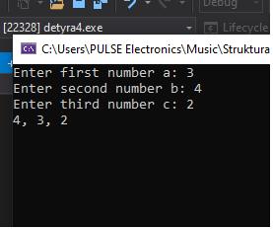

1. Write a program that asks for a digit (0-9), and depending on the input, **shows the digit as a word** (in English). Use a **switch** statement.

using System;

namespace detyra5

{

class Program

{

static void Main(string[] args)

{

Console.Write("Enter first number: ");

int number = Int32.Parse(Console.ReadLine());

switch (number)

{

case 0: Console.WriteLine("Zero"); break;

case 1: Console.WriteLine("One"); break;

case 2: Console.WriteLine("Two"); break;

case 3: Console.WriteLine("Three"); break;

case 4: Console.WriteLine("Four"); break;

case 5: Console.WriteLine("Five"); break;

case 6: Console.WriteLine("Six"); break;

case 7: Console.WriteLine("Seven"); break;

case 8: Console.WriteLine("Eight"); break;

case 9: Console.WriteLine("Nine"); break;

default: Console.WriteLine("Wrong input"); break;

}

}

}

}

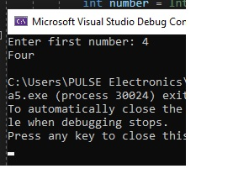

1. Write a program that gets the coefficients ***a***, ***b*** and ***c*** of a quadratic equation: ***a*x2** **+** ***b*x** **+** ***c***, calculates and prints its real roots (if they exist). Quadratic equations may have 0, 1 or 2 real roots.

using System;

namespace Chapter_5_Solution_6

{

class Program

{

static void Main(string[] args)

{

Console.Write("Jepni a por jo 0 A: ");

sbyte a = Convert.ToSByte(Console.ReadLine());

Console.Write("Jepni B: ");

sbyte b = Convert.ToSByte(Console.ReadLine());

Console.Write("Jepni C: ");

sbyte c = Convert.ToSByte(Console.ReadLine());

sbyte d = (sbyte)(b * b - 4 * a * c);

if (d < 0)

Console.WriteLine("\nD={0}\nThere are no real roots.", d);

else if (d == 0)

{

sbyte x1 = (sbyte)(-b / 2 * a);

Console.WriteLine("\nX={0}", x1);

}

else

{

sbyte x1 = (sbyte)((-b + Math.Sqrt(d)) / (2 * a));

sbyte x2 = (sbyte)((-b - Math.Sqrt(d)) / (2 * a));

Console.WriteLine("\nX1={0}\nX2={1}", x1, x2);

}

Console.ReadKey();

}

}

}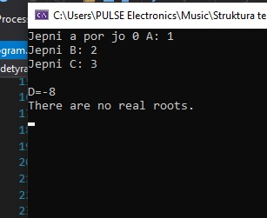

1. Write a program that finds the **greatest of given 5 numbers**.

using System;

namespace detyra7

{

class Program

{

static void Main(string[] args)

{

Console.Write("Enter first number: ");

int a = Int32.Parse(Console.ReadLine());

Console.Write("Enter second number: ");

int b = Int32.Parse(Console.ReadLine());

Console.Write("Enter third number: ");

int c = Int32.Parse(Console.ReadLine());

Console.Write("Enter fourth number: ");

int d = Int32.Parse(Console.ReadLine());

Console.Write("Enter fifth number: ");

int e = Int32.Parse(Console.ReadLine());

if (a < b) a = b;

if (a < c) a = c;

if (a < d) a = d;

if (a < e) a = e;

Console.WriteLine("{0} is the biggest number.", a);

}

}

}

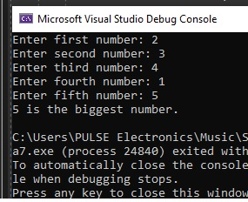

1. Write a program that, depending on the user’s choice, inputs **int**, **double** or **string** variable. If the variable is **int** or **double**, the program increases it by 1. If the variable is a **string**, the program appends "**\***" at the end. Print the result at the console. Use **switch** statement.

using System;

namespace detyra8

{

class Program

{

static void Main(string[] args)

{

Console.Write("Enter variable type (0 - int, 1 - double, 2 string): ");

int intVar = Int32.Parse(Console.ReadLine());

switch (intVar)

{

case 0:

{

Console.Write("Enter int variable: ");

intVar = Int32.Parse(Console.ReadLine());

intVar++;

Console.WriteLine("Int variable +1 = {0}", intVar);

break;

}

case 1:

{

Console.Write("Enter double variable: ");

double doubleVar = double.Parse(Console.ReadLine());

doubleVar++;

Console.WriteLine("Double variable +1 = {0}", doubleVar);

break;

}

case 2:

{

Console.Write("Enter string variable: ");

string stringVar = Console.ReadLine();

stringVar = stringVar + '*';

Console.WriteLine("String variable +* = {0}", stringVar);

break;

}

default: Console.WriteLine("Wrong input"); break;

}

}

}

}

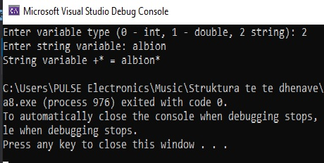

9.    We are given 5 integer numbers. Write a program that finds those **subsets whose sum is 0**. Examples:

-     If we are given the numbers {3, -2, 1, 1, 8}, the sum of -2, 1 and 1 is 0.

-     If we are given the numbers {3, 1, -7, 35, 22}, there are no subsets with sum 0.

using System;

namespace detyra9

{

class Program

{

static void Main(string[] args)

{

Console.Write("Enter first number: ");

sbyte first = Convert.ToSByte(Console.ReadLine());

Console.Write("Enter second number: ");

sbyte second = Convert.ToSByte(Console.ReadLine());

Console.Write("Enter third number: ");

sbyte third = Convert.ToSByte(Console.ReadLine());

Console.Write("Enter fourth number: ");

sbyte fourth = Convert.ToSByte(Console.ReadLine());

Console.Write("Enter fifth number: ");

sbyte fifth = Convert.ToSByte(Console.ReadLine());

if (first + second == 0)

Console.WriteLine("{0}+ {1} = 0", first, second);

if (first + third == 0)

Console.WriteLine("{0}+ {1} = 0", first, third);

if (first + fourth == 0)

Console.WriteLine("{0}+ {1} = 0", first, fourth);

if (first + fifth == 0)

Console.WriteLine("{0}+ {1} = 0", first, fifth);

if (second + third == 0)

Console.WriteLine("{0}+ {1} = 0", second, third);

if (second + fourth == 0)

Console.WriteLine("{0}+ {1} = 0", second, fourth);

if (second + fifth == 0)

Console.WriteLine("{0}+ {1} = 0", second, fifth);

if (third + fourth == 0)

Console.WriteLine("{0}+ {1} = 0", third, fourth);

if (third + fifth == 0)

Console.WriteLine("{0}+ {1} = 0", third, fifth);

if (fourth + fifth == 0)

Console.WriteLine("{0}+ {1} = 0", fourth, fifth);

if (first + second + third == 0)

Console.WriteLine("{0}+ {1}+ {2} = 0", first, second, third);

if (first + second + fourth == 0)

Console.WriteLine("{0}+ {1}+ {2} = 0", first, second, fourth);

if (first + second + fifth == 0)

Console.WriteLine("{0}+ {1}+ {2} = 0", first, second, fifth);

if (first + third + fourth == 0)

Console.WriteLine("{0}+ {1}+ {2} = 0", first, third, fourth);

if (first + third + fifth == 0)

Console.WriteLine("{0}+ {1}+ {2} = 0", first, third, fifth);

if (second + third + fourth == 0)

Console.WriteLine("{0}+ {1}+ {2} = 0", second, third, fourth);

if (second + third + fifth == 0)

Console.WriteLine("{0}+ {1}+ {2} = 0", second, third, fifth);

if (third + fourth + fifth == 0)

Console.WriteLine("{0}+ {1}+ {2} = 0", third, fourth, fifth);

Console.ReadKey();

}

}

}

10.   Write a program that applies **bonus points** to given scores in the range [1…9] by the following rules:

-     If the score is between 1 and 3, the program multiplies it by 10.

-     If the score is between 4 and 6, the program multiplies it by 100.

-     If the score is between 7 and 9, the program multiplies it by 1000.

-     If the score is 0 or more than 9, the program prints an error message.

using System;

namespace detyra10

{

class Program

{

static void Main(string[] args)

{

byte points;

Console.Write("Enter points between 1 and 9: ");

points = Convert.ToByte(Console.ReadLine());

if (points >= 1 && points <= 3)

Console.WriteLine("Points multiplied by 10: {0}", points * 10);

else if (points >= 4 && points <= 6)

Console.WriteLine("Points multiplied by 100: {0}", points * 100);

else if (points >= 7 && points <= 9)

Console.WriteLine("Points multiplied by 1000: {0}", points * 1000);

else

Console.WriteLine("Wrong Input!");

Console.ReadLine();

}

}

}

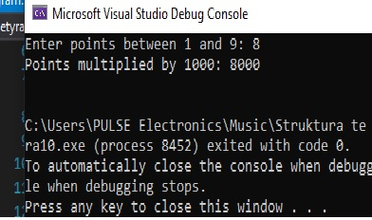

11.   * Write a program that **converts a number in the range [0…999] to words**, corresponding to the English pronunciation. Examples:

-     0 --> "Zero"

-     12 --> "Twelve"

-     98 --> "Ninety eight"

-     273 --> "Two hundred seventy three"

-     400 --> "Four hundred"

-     501 --> "Five hundred and one"

-     711 --> "Seven hundred and eleven"

using System;

namespace detyra11

{

class Program

{

static void Main(string[] args)

{

{

Console.Write("Enter a number between 0 and 999: ");

short number = Convert.ToInt16(Console.ReadLine());

byte hundreds = (byte)(number / 100 | 0);

byte tensAndOnes;

if (number > 99) tensAndOnes = (byte)(number % 100);

else tensAndOnes = (byte)(number * 1);

byte ones = (byte)(number % 10);

switch (hundreds)

{

case 1: Console.Write("One hundred "); break;

case 2: Console.Write("Two hundred "); break;

case 3: Console.Write("Three hundred "); break;

case 4: Console.Write("Four hundred "); break;

case 5: Console.Write("Five hundred "); break;

case 6: Console.Write("Six hundred "); break;

case 7: Console.Write("Seven hundred "); break;

case 8: Console.Write("Eight hundred "); break;

case 9: Console.Write("Nine hundred "); break;

}

if (hundreds >= 1 && tensAndOnes >= 1) Console.Write("and ");

if (tensAndOnes >= 20 && tensAndOnes < 30) Console.Write("Twenty");

else if (tensAndOnes >= 30 && tensAndOnes < 40) Console.Write("Thirty");

else if (tensAndOnes >= 40 && tensAndOnes < 50) Console.Write("Fourty");

else if (tensAndOnes >= 50 && tensAndOnes < 60) Console.Write("Fifty");

else if (tensAndOnes >= 60 && tensAndOnes < 70) Console.Write("Sixty");

else if (tensAndOnes >= 70 && tensAndOnes < 80) Console.Write("Seventy");

else if (tensAndOnes >= 80 && tensAndOnes < 90) Console.Write("Eighty");

else if (tensAndOnes >= 90 && tensAndOnes < 100) Console.Write("Ninety");

switch (tensAndOnes)

{

case 1: Console.Write("One"); break;

case 2: Console.Write("Two"); break;

case 3: Console.Write("Three"); break;

case 4: Console.Write("Four"); break;

case 5: Console.Write("Five"); break;

case 6: Console.Write("Six"); break;

case 7: Console.Write("Seven"); break;

case 8: Console.Write("Eight"); break;

case 9: Console.Write("Nine"); break;

case 10: Console.Write("Ten"); break;

case 11: Console.Write("Eleven"); break;

case 12: Console.Write("Twelve"); break;

case 13: Console.Write("Thirteen"); break;

case 14: Console.Write("Fourteen"); break;

case 15: Console.Write("Fifteen"); break;

case 16: Console.Write("Sixteen"); break;

case 17: Console.Write("Seventeen"); break;

case 18: Console.Write("Eighteen"); break;

case 19: Console.Write("Nineteen"); break;

}

if (tensAndOnes > 20)

{

switch (ones)

{

case 1: Console.Write("-one"); break;

case 2: Console.Write("-two"); break;

case 3: Console.Write("-three"); break;

case 4: Console.Write("-four"); break;

case 5: Console.Write("-five"); break;

case 6: Console.Write("-six"); break;

case 7: Console.Write("-seven"); break;

case 8: Console.Write("-eight"); break;

case 9: Console.Write("-nine"); break;

}

}

if (number == 0) Console.Write("Zero");

Console.ReadKey();

}

}

}

}

